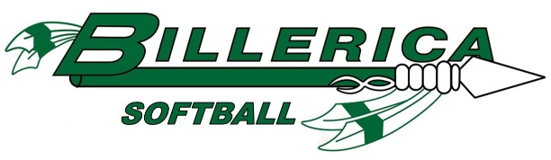

2020 Billerica Softball Tournament Registration Form
Team Name: __________________________________
Program Name (if applicable):_________________________
Name as it should appear on tournament info/shirts, etc:_________________________

ASA Age Group (select one): 10U 12U 14U 16U 18U

Tournament Name (circle one):
Spring Fling 12U C – May 29th | Summer Sizzler 16U Open – July 24th
Spring Fling 14U B – May 29th | Summer Sizzler 18U Open – August 7th
Summer Sizzler 10U Open – July 24th

Head Coach Name: ___________________________________
Head Coach Cell Phone:________________________________
Head Coach Email Address:_____________________________

Payment will be made by:
Check payable to ‘Billerica Softball’ and mail to Tournament Director, PO Box 204, Billerica, MA 01821
Venmo to @BillericaSoftballAssociation

Reserved for Billerica Softball Use:

