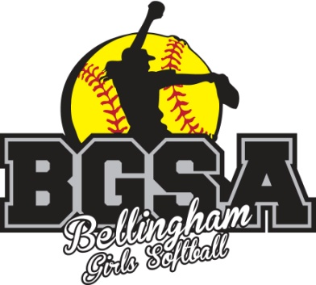
Bellingham Girls Softball Association
2022 Bellingham Bash Tournament
8U Division - Class: C

Registration Form

Team Name: _____________________________________________

Team Contact/Coach: _____________________________________

Email Address: ___________________________________________

Address: ________________________________________________

City/State: _______________________________ Zip: ___________

Telephone: _____________________________

Registration Fee: $500 per team

Make Checks Payable to: Bellingham Girls Softball Association (BGSA)

Send Applications & Checks to:
BGSA
P.O. Box 851
Bellingham, MA 02019

All payments must be received 60 days prior to the start of the tournament with no exceptions! Refunds will be considered but not guaranteed if deadline has been exceeded.

Tournament Sanctioned by the USA Softball MA. Teams must be registered through the Mass ASA an
and listed on www.majoasa.org at least one week prior to the event. For additional information, please
contact Billy Clinton at clintonplumbing@hotmail.com

