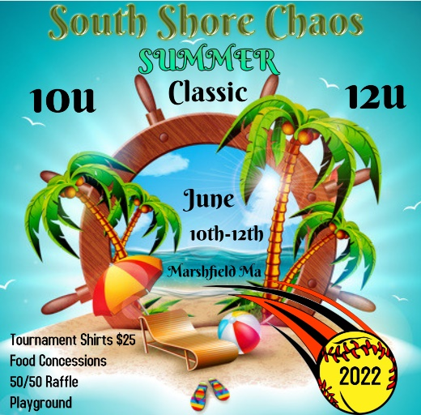

Tournament rules and Information

1. Managers will need to provide their signed USA Softball Roster and insurance binder by
email before June 1st. Please send them to jwkempton79@msn.com.
2. All coaches will need to be ready to show their USA Softball background and
SafeSport certification card supplied by USA Softball. This is a requirement to be on
the field and in the dugout. If a coach is not able to provide these credentials they will be
asked to leave the field immediately.
3. Be sure to check in with the tournament director at least one hour prior to your first
scheduled game time. Check-in is at main gate
4. One MVP pin will be exchanged after each pool play game on Friday and Saturday.
MVP.Pins will be provided by South Shore Chaos.

Conduct:
A. Team managers and coaches are responsible for the team parents and fans on their
side of the field.
B. Any display of poor sportsmanship by players, coaches, parents, or fans will result in
automatic expulsion from that game and at least the next game at the discretion of the
tournament director. Any coach being ejected must leave the area of the field
immediately.
C. It is the policy of the USA Softball of Massachusetts and it’s Commissioner’s staff to
enforce the Taunting Policy at all tournaments. We implore all coaches, players and
spectators, etc. to refrain from any type of taunting. Taunting shall include any action or
comments, which are intended to bait, anger, embarrass, ridicule, or demean others,
whether or not deeds or words are vulgar or racist. No artificial noise makers of any
type, horns, whistles, etc… will be allowed.

**These are public school grounds, and everyone must adhere to the following***
A. No open fires or barbecues allowed in any part of the complex, including parking lots.
B. No alcohol.
C. No dogs or other animals allowed unless indicated for medical necessity. Please
let your parents know that they will be asked to leave if they bring their dogs to
our fields!
D. No smoking allowed in the complex.
F. No PARKING on any grass surfaces

Tournament Rules
The tournament rules can be found in the USA Softball of Massachusetts Youth Fast Pitch
Tournament Rules.
Game Time Limit - Game time will be 1 hour 20 minutes and finish the inning. Then play one
additional inning or half inning if the home team is ahead.
For Pool Play games if teams play all 7 innings and the 1 hour 20 minute time limit hasn’t been
reached, the next inning and the one additional inning will be played with the Tie Breaker Rule.
If the score is tied after the additional inning the game will be considered over.
For Elimination games, if after the additional inning the game is tied, the Tie Breaker rule will be
used until a team is declared the winner. Exceptions to this rule will be allowed in cases of
inclement weather. The Championship game will be 7 innings (no time limit).

Batting Line Up
Teams may choose one of the following formats:
Teams may bat 9 players with or without the DP/Flex.
Teams may bat up to everyone on their roster throughout pool play and elimination
games.

Time limit
The time limit continues to be in effect during a rain delay (Time limit clock
does not stop during the rain delay).

A. If a game is interrupted at the end of an inning, and at least four innings have been
played, and time has expired, the game will be declared complete.
B. If a rain interruption occurs during an inning, and at least four innings have been
completed and time has expired, the game will be declared complete and the score at
the end of the previous inning will be the final score
C. If a rain interruption occurs at any time prior to the completion of 4 ½ innings, the game
will resume at that point and continue until 5 innings have been played. The game will
continue after 5 innings only if the time limit has not expired.
D. Games subsequent to rain delay will remain at 7 innings and a 1 hour and 20 minute
finish the inning and play one additional inning. If in the tournament director’s opinion all
games subsequent to the rain delay should be shortened to 6 innings and a 65 minute
time limit in order to complete the tournament on time, the games will be shortened.
E. Rule D may be applied to any portion of the tournament. If the tournament returns back
to schedule, games may return to the original time limit. This is all at the discretion of
the tournament director.
F. If the rain delay occurs on Sunday and it becomes impossible to complete the
tournament, winners will be determined by the Round Robin tiebreaker rules if no games
have been played. Otherwise, the 2 highest seeded teams will be declared the winner
and runner-up.
G. The tournament director does reserve the right to alter the tournament schedule and/or
format in the event of prolonged or severe weather conditions. Ultimately the objective
of the rain policy is to be fair to all participants and give everyone the number of games
they deserve. The tournament director will strive to be fair to everyone, however there
may be unforeseen circumstances that a totally acceptable conclusion may be possible
Refunds:
If the tournament is shortened due to weather, teams will be entitled to a
refund based on the following formula:
A. If a team plays zero games, the team will be entitled to their entry fee less
non-recoverable tournament expenses. These include but not limited to perishable food,
T-shirts, trophies, game balls and insurance. Tournament will provide USA Softball MA
this calculation within 7 days of the tournament for approval. Once approved, the
tournament director must send each team a copy of this calculation along with their
refund.
B. If one game is played, the refund will be 50% of the registration fee.
C. If two or more games are played, no refund will be given.
D. Tournaments must refund teams within 14 days from when the tournament was
scheduled.
Umpires:
1 umpire for pool play games and for single elimination games. 2 umpires for semi-finals & Finals

