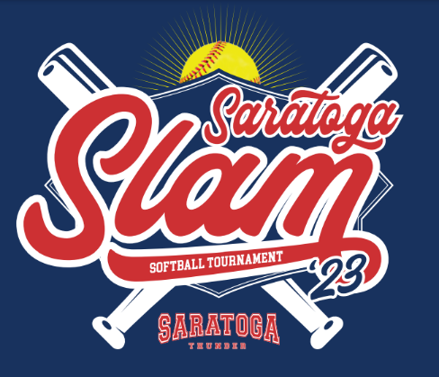
2023 Saratoga Thunder
USA Softball Tournament Information
8U Saratoga Slam
June 10th – 11th
Veterans Memorial Park

Contacts

League President
Alison Gilcreast
860-395-9202
President.SaratogaMiss@gmail.com

Saratoga Thunder 8U Head Coach
Vince Laurenzo
vlaurenzo@qrrestore.com
201-919-5106

For all inquiries, please email info.saratogamiss@gmail.com

Participating Teams
Thank you to all the teams for choosing Saratoga Thunder 2023 8U Tournament.
The following teams are participating:

Saratoga Thunder
Classie Lassie Nor'easter
Titans Fastpitch Red
Halfmoon Lightning Black
Mid-Hudson Rebels
Miss Scotties Crushers

Schedule
  - The game schedule for both pool play games as well as championship play games can be found at www.itournamentbrackets.com. Click on New York and then click on Softball.
  - The results of the pool play games as well as the bracket schedule will also be available on that webpage. Please note that it is imperative that all pool play scores be reported to the Tournament Director promptly so that the publication of the championship play brackets can take place as soon as possible.

Team One |  | Team Two | Location | Game Date | Time
Saratoga Thunder |  | Classie Lassie Nor'easter | Field 1 | Sat, Jun 10 | 10:00 AM
Titans Fastpitch Red |  | Halfmoon Lightning Black | Field 2 | Sat, Jun 10 | 10:00 AM
Mid-Hudson Rebels |  | Miss Scotties Crushers | Field 4 | Sat, Jun 10 | 10:00 AM
Saratoga Thunder |  | Titans Fastpitch Red | Field 1 | Sat, Jun 10 | 12:00 PM
Classie Lassie Nor'easter |  | Mid-Hudson Rebels | Field 2 | Sat, Jun 10 | 12:00 PM
Halfmoon Lightning Black |  | Miss Scotties Crushers | Field 4 | Sat, Jun 10 | 12:00 PM
Saratoga Thunder |  | Halfmoon Lightning Black | Field 1 | Sat, Jun 10 | 2:00 PM
Classie Lassie Nor'easter |  | Miss Scotties Crushers | Field 2 | Sat, Jun 10 | 2:00 PM
Titans Fastpitch Red |  | Mid-Hudson Rebels | Field 4 | Sat, Jun 10 | 2:00 PM

Bracket

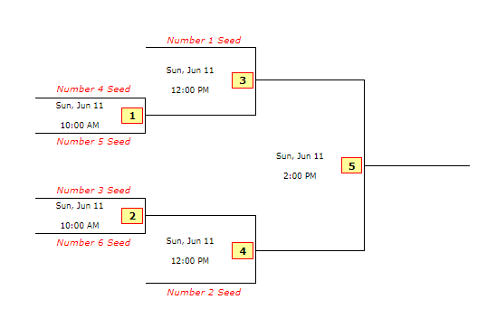

Check- in

You are required to check in at the tournament. Please ensure the league has a current copy of your required documents (identified below) in advance of the tournament. Please have the required documentation on your person for the duration of the tournament:
- USA Softball Roster and Birth Certificates for each player on your roster
- Proof of Insurance

You can email the documents to info.satatogamiss@gmail.com

T-shirts

Your pre-ordered T-shirts can be paid for and picked up at the concession stand when you check in. Payment for T-shirts can be made by check made payable to Saratoga Miss Softball or through PayPal @SaratogaMissSoftball. All shirts are $25.

To place your T-Shirt order please go to https://forms.gle/HQaMMgneoNPjodYz6 no later than June 2nd.

Park Location
Veterans Memorial Park 10 Adams Road, Saratoga Springs, NY 12866

Main lot gets filled fast (Foul balls dangerous to cars). 100 yards down on the left is a second lot (more car friendly). Another 100 yards is a third lot. Parking on the side of the road is permitted on the FIELD SIDE ONLY. NO PARKING on the Ball Metal Inc. side or on Cady Hill Blvd., tickets will be issued

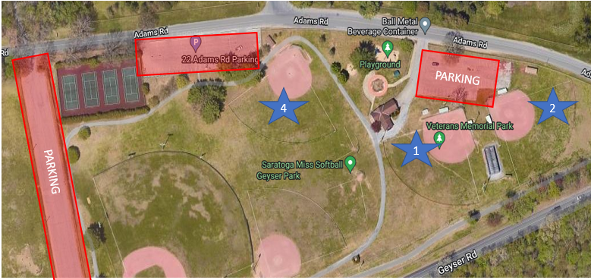

Park Rules:
- DOGS: NOT ALLOWED IN PARK DUE TO CITY ORDINANCE!!! PLEASE INFORM YOUR PARENTS. WE DO NOT WANT TO SEE DOGS IN CARS. PLEASE INFORM PARENTS.
- ALCOHOL and SMOKING IS NOT PERMITTED IN PARK. Any violations will result in individual(s) being asked to leave the park.

Rain out / Refund policy

In the event that Saturday games are rained out, we will have pool play games on Sunday with the winner crowned based on seeding. In the event pool play games are played on Saturday but no championship games played on Sunday, Saturday’s pool play seeding will determine the winner. The tournament director reserves the right to change, shorten, modify, or alter the games and/or schedule to conclude the tournament successfully. If no games are played, each team will be refunded 75% of their entry fee. If your team plays one game, your team will be refunded 50% of their fee. If two or more games are played, there will be no refund.

Tournament Rules
8U Hudmo Rules

- Time limit will be 1 hour and 20 minutes, finish the inning, unless the home team is ahead after the top of the inning

- A coach of the team that is batting will pitch. Each batter will be pitched a maximum of 6 pitches. If still at the plate after the 6th pitch has been thrown (and the 6th pitch was not fouled off), the batter will be declared out. Balls and strikes are not called, only the amount of pitches thrown will be counted. A batter can strike out swinging. The at bat cannot end on a foul.

- There is no bunting allowed and dropped 3rd strike does not apply to this division.

- A safely hit ball to the infield will allow both the batter and all base runners to try and advance onebase with the liability of being put out (regardless if a play is made on them or not – it is still one base.

- A safely hit ball to the outfield grass, whether in the air, on the ground, or after being touched by a defensive player (ball must reach the outfield grass) allows both the batter and all base runners to advance with the liability of being put out until the ball is returned to the infield (crosses dirt/grass line). Once the ball crosses into the infield, no advance beyond the base the runner is going to regardless of overthrows etc.

- Base Runners cannot leave their base until the ball crosses the plate. First time a team has runners leave early the umpire will issue a warning , subsequent leaving early will be an out. As always, Runners taking a lead as the ball crosses the plate are subject to being put out by the defense.

- A defensive player will occupy the pitchers position on either side of the adult pitcher. Player must stay inside (one foot) the pitchers circle until the ball is hit.

- Any batted ball touching the adult pitcher will constitute play being halted and no pitch being declared. The batter will return to the plate and resume the previous count, all base runners will return to the bases previously occupied. The adult pitcher must immediately attempt to get out of the way of defensive players once the ball has been pitched, and cannot impede a player from making a catch or throw. If in the umpire's discretion it is believed that the adult pitcher has violated this rule, the batter will be called out and all base runners returned to the base that they previously occupied.

- Two coaches are allowed to be on the field to provide instruction when his/her team is on defense, both must be in the outfield grass. If a coach that is on the field with the defensive team is struck by a batted ball, the batter and all base runners will be awarded (2) bases.

- Games will be 6 innings in length, unless shortened by the run ahead rule. Games can end in a tie. No new inning will begin after 80 minutes.

- Run ahead rule: If a team is ahead by 12 runs after 3 complete innings or 10 runs after 4 complete innings or 8 runs after 5 completed innings, the game is over.

- A maximum of 4 runs can be scored in all innings except for the last inning where runs scored are unlimited. The last inning is the 6th inning only.

- For obvious reasons, there will be no infield fly rule in this division.

- The umpire will make all calls.

- A continuous batting order can to be used (all players bat). Should a player be unable to take her turn at bat for any reason, proceed to the next scheduled batter without penalty. The player that was unable to take her turn at bat is out of the lineup, and cannot return to that game. Free defensive substitutions when continuous batting order is used. Otherwise standard substitution rules apply (player cannot play in field unless in batting order, cannot come out of lineup unless played the field and batted).

- Pitching distance will be 30 feet for this division. Base distance will be 60 ft.

- 11" hard softballs will be used.

- 10 defensive players are allowed in the field, 6 in the infield, 4 in the outfield. The four outfielders must start on the outfield grass; An outfielder cannot make a play in the infield unless the play is unassisted, (i.e. an outfielder cannot play over the second base bag and accept throws).

- A game is expected to begin with 10 players but can play with 9 without penalty if 10 are not available. If playing with 8 (minimum allowed) team must take out for 9th batter. There is no penalty for having to drop from 10 to 9 players during a game due to injury/illness. Failure to have the required number of players to start or continue a game (eight) will result in a forfeit. If a game is started with fewer than ten players, and a player arrives late, this player can immediately be inserted in the game and will be placed last in the batting order.

- There will be no tag up and advance on a pop fly caught by an infielder. A pop up or fly ball must be caught behind the infielders, by an outfielder in order for a runner to tag up and advance.

- Air horns and other noise makers are not allowed.

- Team cheers will be positive in nature and should be designed to rally the team that is doing the cheering, not to razz the opponent.

- Only the head coach is allowed to speak to the umpire or state official when it comes to interpretation of the 8U playing rules. The game will be stopped and then resumed after clarification of the rule in question is completed. When the game is stopped, the timer is stopped also.

- One USA Umpire will be used for all games. Except there will be two umpire fpr the semi-finals and finals.

